
Getting started with the MITPlayer (Summer 2024 release)
"The only Music Player specifically developed for Folk dance sessions"

 This document is for NEW USERS 

I'm delighted to have you use this new update of the MITPlayer. Neil Rosen started writing his Player a long time ago; that there are dozens of groups using it is a testament to his design skill.
We also owe a profound debt to Charlie Kluepfel, who was looking for a challenging project to work on during the COVID pandemic. He brought both professionalism and creativity to our update effort, often sending a fix or new feature one day after I described it. Some days he sent 3 updates.
This document explains how to Set up (prepping for new install of the MITPlayer) and Wise things to do (backups, checking your dance files, "gotchas"). The larger document, info.mit.group.communications, explains the features in more detail, with Cool features and our Wish list. Even if you're not running a group, I urge you to play around! It's the only way to a) gain familiarity with the features and b) check you're using them correctly.
- Hey, I'm starting fresh!
Put executable and all the key files in a main directory under C:\
(we recommend 'fd' or 'MIT')
For the MITPlayer it's easiest not to use Windows libraries: 'Music' or 'Documents'
or 'My Documents' or 'Program Files'. But if you already used them, see Appendix II.

- Setting up:
The Player uses several directories to organize files created on your behalf. We define the 'Main' directory as your home location for those folders. Your main directory can be C:\fd or C:\MIT or C:\name-of-my-group. Once you create your main directory, create the following subdirectories: favorites, tabs, pictures, program_logs. (Doesn't matter – uppercase, lowercase). The files created by the Player for you will automatically go there.
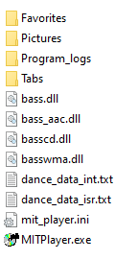
Most of you are starting with a zip file that contains sample music and databases (MITPlayer-plus.db.zip). Put in your main directory: the Player's executable (MITPlayer.exe), all four files starting with bass (bass.dll, etc), the sample initialization file (mit_player.ini) and the small database files, dance_data_int.txt and dance_data_isr.txt, and the batch script, magnify.bat. To get started, move the sample MP3 files into a directory C:\Mx (for Music). You can use your existing music directories later. (See discussion in Appendix II regarding our recommendation against using the Program Files Windows directory.)
The listing in your main directory should look something like this ➔
- Can you make a "How To" video?
Yup, we have tutorials for Novices and Experienced users. Cntl-click these links:
Basics: Here it is
Advanced features: Here that is
Dance Hall Display: Here
These may change over time: always ➔
find the tutorials via the MITPlay site: ➔
or Google "MITPlayer"

How do you contact us?
Contact info on MITPlayer site

Where is MITPlayer's website?
Here's the site

- For Windows 10: READ THIS SECTION even BEFORE downloading:
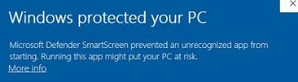
Because we are not a software house with an "Extended Validation Code Signing Certificate" – whatever that means –
when you start the program, or even download to your computer, Windows may emit an unfortunately scary warning:
'Running this app might put your PC at risk'

Trust us, this is Microsoft Defender being unnecessarily defensive. Hit "More Info", then select the option "Run anyway." You will see this only once for each release.
If you don't see "Run anyway", there is an additional step to tell Defender to allow the software. See SmartScreen instructions in Appendix Ia.
- "Search for app in the Store?" You were sent version compiled on our VM. Get a re-compiled version from the site. Doesn't
matter if you say Yes or No, the program will start. This happens *each* time you run the program. Instructions to disable: Disable 'Look for app' msg
- BUT: As soon as you try to download, your VIRUS PROTECTION SOFTWARE MAY STILL IMMEDIATELY REMOVE IT:
You may not even get to the prior stage; your virus software may say "Uh oh, this executable looks like dangerous trojan software". Again, the virus definitions are overly aggressive. See full instructions for handling in the Appendix Ib.
- WHERE DO I GO NOW? If you are starting from the zip file with our sample database and music files, read the section immediately below – 1a. If instead, you are starting with a "fresh start," minimum zip file (not generally available), with only the program executable and the Bass dll's, SKIP to 1b.

- 1a. Starting up: USING ZIP FILE WITH SAMPLE FILES (MITPlayer-plus.db.zip)
Congratulations! A lot of the setup work has been done for you – you have some sample music files, a sample database, and useful program options are already selected for you. You'll add your own music files later.
- Unzip the files and put them in your 'main' directory, what will be home location for the Player and its files. Your main directory can be C:\fd or C:\MIT or C:\name-of-my-group. In your main directory, create the following subdirectories: favorites, tabs, pictures, program_logs. (Doesn't matter – uppercase, lowercase).
- Create the directory C:\Mx (for Music) and move the sample mp3's there. (Later, you'll add your own music, pointing the program to files anywhere on your laptop, and remove these sample files later.)
- The remaining files in the zip archive should go in your main directory.
- Start the Player app (click on the executable MITPlayer.exe).
- Bring up the setup screen (main menu: Options/Setup Screen - keyboard shortcut: Cntl-I) [that's an 'i'], then verify the path for the sample MP3s is correct (your C:\Mx directory).
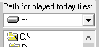
- If you called your main directory something different than C:\fd, navigate to the correct location so that the "Path for dances played today" points to Program_Logs.

- See the location for the Registration code? At some point, get the code from us. First send us your laptop code found in the menu: Help/About or the Setup Screen. Then enter your registration on the setup screen. Registration is free.
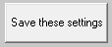
- Hit Save these settings:

Now play with the MITPlayer a bit.
The basic interface: The Program panel is your playlist. Holder is a "scratch pad" area for dances you might do later.
The Selector panel shows your entire dance repertoire. This can be filtered using the various buttons to the Right. After your dances have been categorized, you can quickly look for medium difficulty Romanian dances; or couple dances choreographed by Gadi; or dances led by Fred, one of the leaders in your group.
It's beyond the scope of this document to explain every feature. For that I recommend either watching both tutorial vids and/or reading the larger info.MIT.group.communications documentation.
Once confident of the basics, you should add your own music.
- The first step: Orient the program to your music location. Bring up the setup screen. Menu option: Options/ Setup Screen. Change the "Initial path to MP3s" to navigate to the top-level location where your music is. This is described in step #5 in the FRESH START section below.
- Make other option changes you like. The type captions, repertoire settings, programer names and database nicknames you have now are all simple examples. Change the type captions to match meaningful categories you want for your music. This isn't required – your entire collection can be a single category, but most groups find it useful to search for dances based on type: eg, line, couple, set, whatever. Give this some thought before proceeding.
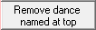
- Then add your music. This is described in steps #14-15 in the 1b. FRESH START section.
To [later] remove the sample files you started with, Right Click their names, on the pop-up choose:
- I also recommend reading though the rest of the FRESH START section to understand the other setup options.
- Now skip to Section 2: Using the MITPlayer.

- 1b. Starting up: COMPLETELY FRESH START, WITHOUT DEMO FILES
If you only have the Bass dll's and the executable, here's what you should do:
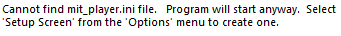
- Start the Player app (click on the executable MITPlayer.exe).
You will get a warning:
- Hit OK.
Program will start, with blanks for just about everything.
- From the menu bar, choose Options, then Setup Screen (keyboard shortcut: Cntl-I) [that's an 'i']
Let's set the bare essentials for now. You'll come back to this screen as you learn to personalize the Player for your needs.
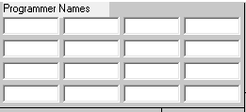
Working from left to Right, on top then down:
- It's not necessary, but you may type in your Programmer Name(s):
Each programmer can have their own list of favorites stored.

- On the Right top, see Registration Code. Get from us after sending your program number in Help/About. Registration is free. If you rely on the Player after awhile, consider sending the small donation described there.

- For Initial path for MP3 files:
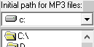
Navigate to the base location of all your music files. It is recommended to put your folkdance music in a drive under C:\, such as C:\music, C:\folkdance, etc. If you have already put your music in the Windows Music library, see instructions in Appendix II. Make sure Initial MP3 Path is set correctly.

- Path for dances played today:
Navigate to the path for Program_Logs, the subdirectory you created under your main directory.


In the color boxes, place meaningful categories for different types of dances. This isn't required – your entire collection can be a single category, but most groups find it useful to search for music based on type: eg, line, couple, set, whatever. Give this some thought before proceeding.
- Type Captions:

- Style Captions: On the other hand, most groups do not use these. You can set these later if you want.
Repertoire Captions: Some groups find them useful. Best to look at the Basics tutorial of the two "How To" videos for an explanation of how to set and use Types, Styles and Repertoires.
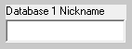
- Enter a nickname for at least Database 1: International, Israeli, Tuesday Night.
If you have two groups that have completely distinct repertoires, with no overlap, then set up the program with 2 different databases and name them accordingly.
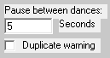
- Choose your preference for your standard interdance pause (this default
can be dynamically overridden on the main programming screen).
Also recommend choosing the duplicate warning – it's a handy setting.
- Hit Save these settings:

- After asking which programmer is "on" tonight, the Player will inform you there are no dances listed: Hit OK.
- Now let's add music to the database. All you have to do is tell the Player where your music is.
There are 3 ways to do this.
a) Absolute fastest is the drag 'n' drop method. Pull dances (singles or multiples) from the File Explorer into the Player. Dances dragged into a) the Program panel are added the program queue; b) to the Holder are added to that scratch pad area; and c) to the Selector are only added to the database. Disadvantage: All dances will be categorized the same – with the country of Mars, because they came from "outer space," ha ha. [NOTE: Next release is changing and improving this procedure and function]
b) The medium speed way uses the menu option: Add Dances/Add a Group
There you will given the option to select all the dances in a directory (or all dances in all its subdirectories). (First select the directory.) Set as many of the categorizations as you like: country, dance type, complexity, etc. Press "?" for more info.
Downside: All dances are categorized using those settings. Highly useful if your dance folders are organized by choreographer, or country, or type: just choose the appropriate settings and click:
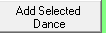
c) The most precise way to add dances uses the menu selection: Add Dances/Add Individual Dance
Here you can set the properties for each dance you select: its dance type, country, complexity, preferred version, repertoire. At the top of the screen, you can change "Name:" that the Player will display for this dance. At the bottom, you add comments, which can be who leads the dance, cues for dance steps, or any information you might want to search later. Press "?" for more info. When done, click: Then press the Quit button.

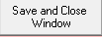
- At this point, you can start playing your dance and enjoying all the features of the Player. At any time, you can go back and recategorize your dances. If they're all labeled as Mars, or as line dances, whatever, you can update this information. To update the data for any dance, Right Click on the dance name in the selector panel. This brings up a Update Dance screen similar to the "Add a dance" form you already saw. You can change any of the information: the display name, it's assigned country, type, difficulty, repertoire, bolding, comments. When done, hit:

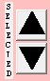
- A cool feature allows you to cycle through all dances needing correction. Before bringing up the Update Dance screen, use the Selector's search criteria to find them. For example, search for Country 'Mars'. Then Right Click
any dance shown, correct its data properties, then click the up/down arrows next to the "Selected" label.
This will quickly help you correct all dances with the choosen feature. Now the database knows where
your dances are, and their properties. Let's play dances and set up a program!

- 2. Using the MITPlayer
The basic interface: The Program panel is your playlist. Holder is a "scratch pad" area for dances you might do later.
The Selector panel shows your entire dance repertoire. This can be filtered using the various selectors to the Right. After your dances have been categorized, you can quickly look for medium difficulty Romanian dances; or couple dances choreographed by Gadi; or even dances led by Jessie, one of your dance leaders. You can also define country groupings to search by region (Balkan, South American, etc).
Other features include: a clean Dance Hall display that shows previous, current and upcoming dances in a large font for the dancers in the room; easy-to-see progress bar; optional country or choreographer pictures for each dance; easy creation of playlists; function keys for keyboard shortcuts and remote control ; dynamic control of inter-dance pauses; "teasers" (which play a dance snippet to alert dancers that a couple or set dance is upcoming); dance search via whole word or sub-strings; automatic memory of dance volume settings; tempo control; optional delayed play (so programmer can lead a dance that starts immediately); automatic storage of teaching dates for dances; selection of dances from previously played programs; color theme personalizations; frequency counts of past programs over any time period; storage of favorites for each programmer; easy database backups; "tooltips" that show completion times for any dance in the program; and much more.
It's beyond the scope of this document to explain every feature. To learn, watch both tutorial videos and read the fuller info.MIT.group.communications document, in Existing users documentation (and advanced topics) on the MITPlayer site.
Before using the Player extensively, read Section 3, a brief discussion of shortcomings to be aware of.

- 3. Wise things to do (aka Recommended actions, plus miscellaneous shortcomings)
After adding any number of dances to your database, we urge you to back up your database. The menu option File/Backup Database (shortcut: Cntl-B) will copy the database file, naming it with the _bu suffix. If you ever want to go back one version, the menu option: File/Read Database from Backup does exactly that. Always do backups!
Each of the following shortcomings is described in more detail in the larger document, info.mit.group.communications.
 NB: This you must NOT do: Move a music file to a different location or rename a file – outside of the Player. The Player can't know you've done this, the database will be out of sync with your files, and won't find them when you ask it to play the moved/renamed file. [The utility option Search for Lost Music attempts to find the exact same filename somewhere in your directories. That's useful but not perfect, as it looks for the original filename.]
 The MITPlayer cannot load filenames with unsupported characters: a number of miscellaneous accented letters, and all languages that use non-Latin/non-English scripts. Either re-spell (rename) or copy the file using English letters and supported letters (see Utilities/Accented Letters for a facility to do that). We also have the Google sheet Help me rename my files! that automatically creates several suggestions for a list of accented files.
 Because the dance db is a plaintext file, it is tempting for some people to edit it manually. Resist this impulse! The Player is very fussy about format, and you can destroy the db without realizing it (cf. advice about backing up database).
To check the validity of your database (file locations, durations, etc) use the menu option: Utilities/Recheck Database (shortcut: Cntl-R). A file analyzing the results is written to your main directory.
 If your group relies extensively on a music collection with fully-populated mp3tags/id3tags, you can use our utility program MITdb Macro to create a complete MIT database from them (with country, choreographer/teacher, comments, prefered display name) if your tags contain that data. Follow the steps in How convert ID3 tags to an MIT database on the MITPlayer site.

Have fun and Enjoy!
Thanks,
The MITPlayer Team
- Hey, things aren't working!
Send us your .ini file, the db file(s) [dance_data*txt].
A screenshot of files in your main directory, setup screen and anything else you think is relevant will also help.

- Got a database without countries or just "Mars"?
Charlie's "MIT Database Updater" is a stand-alone utility program. The Updater finds matching dance names in your db and assigns the country found in a reference database. Doc is in its own distribution zip file.

Appendix Ia – SmartScreen warnings

- You may not see the "Run anyway" button
Based on other Windows security settings, after you click More Info, you may not be given the opportunity to select "Run anyway".

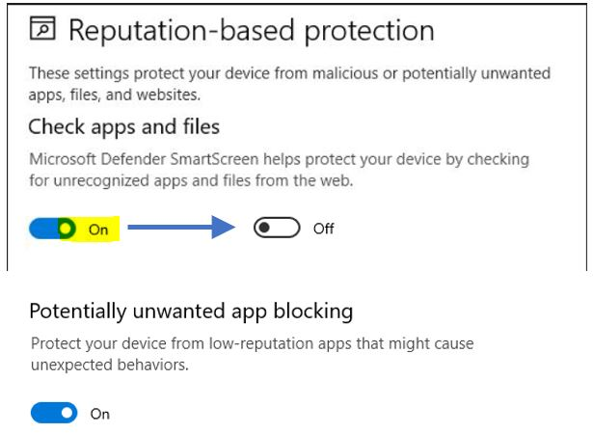
In that case, here's what you need to do:
1) Click the Windows button and type Settings.
Search for "reputation", click Reputation-based protection. Under Check apps and files, turn that off.

(Or search for Windows Security, select App & Browser Control, then Reputation-based protection, then Reputation-based protection settings).

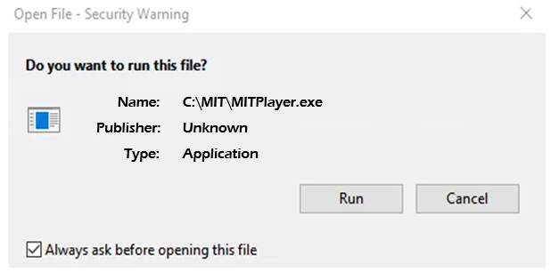
2) When you click on the MITPlayer executable, you will now get a "Do you want to run this file?" security warning.
Uncheck "Always ask," then click "Run"

You will only have to do this once per release. You can go back and reset the reputation-based protection if you want.

To avoid this hassle entirely, Google: Group Policy Editor settings to set Defender to 'warn'.
Appendix Ib – Virus warnings
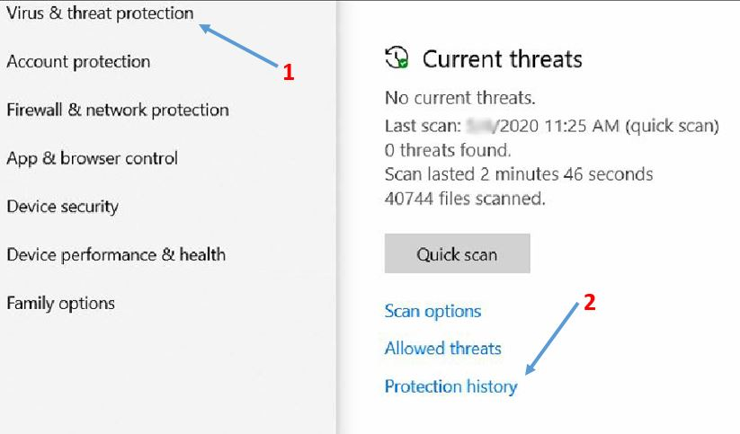
- As soon as you try to download, your virus protection software may immediately remove the Player * READ FOOTNOTE
[Instructions for Windows10/11]
Your virus software may say 'Uh oh, this executable contains dangerous Trojan software'. If the file "disappears" after attempting a download, here's how to correct that.
+ Click the Windows button, and type Defender.
Open Windows Defender, click Virus & threat protection, then Protection history.
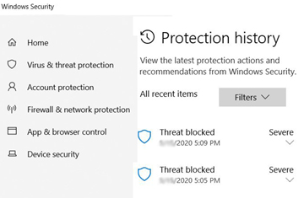

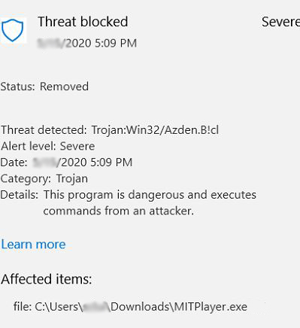
+ Click the arrow (under Severe) associated with your last download

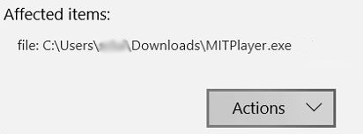

+ Click 'Actions', choose Allow and then Restore.
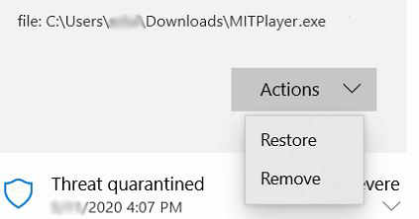
The file will then be restored. Look in the location selected for your other downloads.
When you run it, you may get one more 'Running this app might put your PC at risk' message that I described at the beginning of these instructions. You'll only have to click 'Run anyway' once. Until our next update :(
BUT: Windows Defender may remove the file after using it a few weeks.
You should add the Player to Defender's exclusion list, using the following steps. (Also save a copy of the executable on a thumbdrive.)
Click Windows button, type Defender, hit Enter. Go to Settings tab, select Excluded Files & Locations.
OR Click Virus & threat protection / Click Virus & threat protection settings / Exclusions / Add or remove exclusions / Add an exclusion. Browse to location of the Player's executable. Add to list of Excluded Files & Locations; do same for Excluded file types and Excluded processes. Click Save.
OR Google how to add exceptions to Windows Defender.
* We've done virus and trojan checks on the Player's executable. Your computer's virus checking, to be fast, looks for code-segment definitions in files; sometime a spurious match marks an innocent file, as happens here.
I (Murray) work for a successor to Bell Labs that does cybersecurity research for the government, specifically DARPA. Recently, our internal security team notified me: one of my files had failed an extensive virus check, it was quarantined, please remove it. [Nothing to do with the Player.] I notified them that the file had been on my computer benignly for 9 years and was not a threat. So this happens all the time.

Appendix II – "I used the Windows Music Folder" or "The Player executable is in Program Files"
I put all my music under the 'Music' folder in Windows. I can't find that folder/directory in the MITPlayer!
I put all my music under a 'Music' folder that's on my Desktop. I can't find that folder in the MITPlayer!
The Music and My Documents folders, even the Desktop, are special Windows folders located in a virtual place on your hard disk. This Appendix explains how to find them. It may cause fewer headaches if you move your music to a folder under your primary (C:) drive, especially if it's a laptop with multiple users. I can explain more, but for now, we recommend moving your music files to something similar to C:\fdmusic, C:\music, etc.
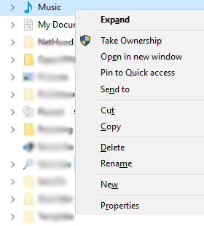
But if you can't (you also use Winamp, MediaPlayer, iTunes or such), or don't want to, follow the instructions below.
1
2
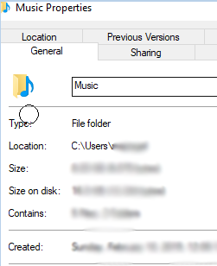
Right Click on the folder icon or directory [1] that contains your music. Select Properties [2]. The next line after Type, you will see Location [3]. It will be of the form C:\Users\[login]\[something]. Take note of this
exact path.
3
Now, open the Player's Setup screen: Utilities/Setup (shortcut Cntl-I),
and for "Click Here/Initial path for MP3 files", click through the folders under
C:\User until you set this precise path to your music files.
+ We still highly recommend putting the Player's directories (Program_Logs,
Favorites, Tabs, Pictures) and program executable in C:\fd, C:\MIT, or
similar location. When you have done so, then set "Path for played today files"
on the Setup Screen to point to the Program_Logs folder.
Once you save the setup file, the Add Dance Individual/Add Dance Group screens will automatically open to the top-level directory where your music files are stored.

I put the Player executable in 'Program Files' – that's a standard place, isn't it?
Yes, it is a standard. But some users have had occasional problem – we're not sure why in each case, but I suspect it's due to Program Files requiring admin/elevated permissions to write files. (The actual files might end up in hidden virtualized folder locations called the VirtualStore.)
Instead, it's never been a problem when the main directory is a separate, new folder off your C: drive, which you will own and have full permissions. So we recommend that.
To fix, all you need to do is move the executable, and the Player's directories as described in the + paragraph above, to a directory you create on your C: drive: again, something like C:\fd or C:\MIT. Be sure to set "Path for played today files" on the Setup Screen as described also. If you have the Player's program logs (files of the form Friday_2020_2_14.txt) left in Window's Program Files directory, move those to your Program_Logs directory under the main Player directory. If you have a shortcut on your desktop for the Player, make sure to point it to your new main directory.
Finally, if your newest files are in some virtualized location like the VirtualStore, copy those files over.

We recommend the USB RF remote from Keith Rubow. Contact Murray for installation details & MITPlayer macros.

